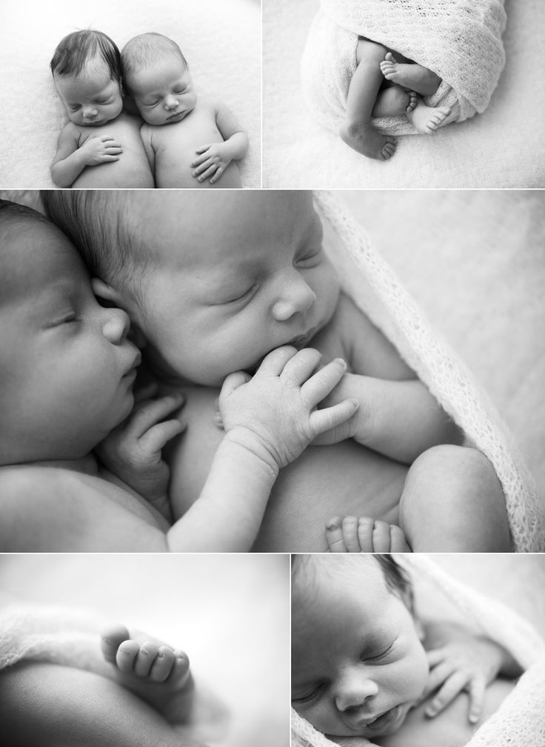

923 Chestnut Street, Orangeburg, SC 29115

**803-937-3010**

Modern Pregnancy and Sexual Health Center

Our Services Include FREE:

* Pregnancy Testing
* Nurse Consultations
* Limited Ultrasounds
* Medical and Adoption Referrals
* Pregnancy Option Counseling
* Parenting Classes

**Office Hours:**

Monday, Wednesday and Thursday

9 A.M. – 5 P.M.

**Because We Care (BWC) Program**

Serving children from birth to no older than 3 years

**Donations Needed**

***Gently Used Items******Must Be******Clean & Stain Free***

***Drop off location: Dazz back door. Look for Dazz sign on the door and call when you arrive.***

**Clothes and Shoes Diapers**

New & Gently Used Clothing Sizes Newborn – 2T All Sizes

Sleepers, Onesies, Outfits, Bibs, Hats, Socks **Greatest Need**: Sizes Newborn, 4, 5 and 6

**Equipment** **Toiletries**

New & Gently Used in Clean & Good Condition:Baby Wipes, Baby Lotion, Shampoo,

Bassinets, Pack-N-Plays, Strollers, Swings, Baby Body Wash, Diaper Cream

Bouncy Seats (NO Baby Powder or Q-Tips)

New Feeding Equipment: Bottles, Bowls, Spoons,

New Mesh Feeders **Other Items**

**Unexpired** Formula

**Sheets and Towels** **Unexpired** Baby Food and Baby Cereal

New & Gently Used Crib sheets, Pack-n-Play and Bassinet sheets,New Pacifiers, Pacifier Clips, Teethers

Blankets, Towels, Wash Cloths, Burp Cloths New & Gently Used Children’s Books

**We** **CANNOT ACCEPT any of the following USED items**: Car Seats, Bumbo Seats, Cribs, Baby Gates, Bumper Pads, Walkers, Stuffed Animals, Diaper Genies, Humidifiers, Potty Seats, Breast Pumps, Feeding bowls/utensils.