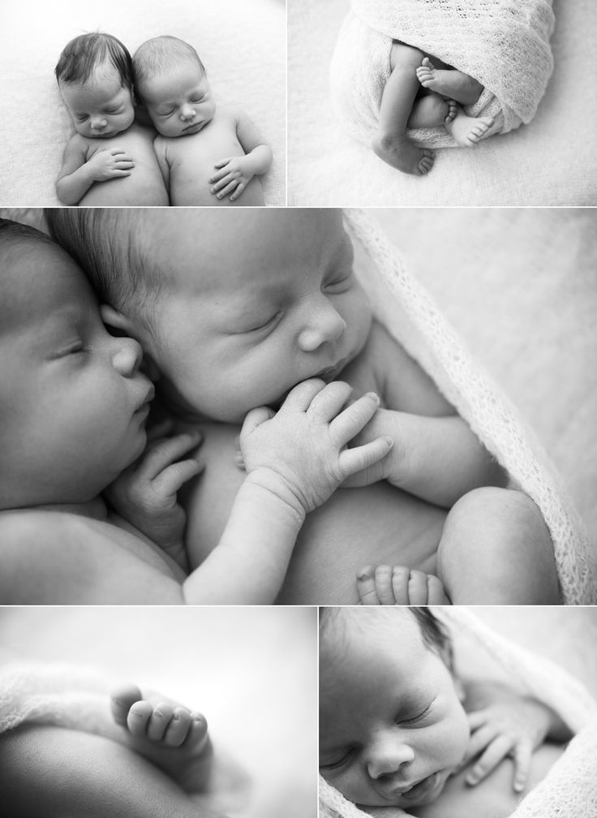
923 Chestnut Street, Orangeburg, SC 29115
803-937-3010
Modern Pregnancy and Sexual Health Center
Our Services Include FREE:

- Pregnancy Testing
- Nurse Consultations
- Limited Ultrasounds
- Medical and Adoption Referrals
- Pregnancy Option Counseling
- Parenting Classes

Office Hours:
Monday, Wednesday and Thursday
9 A.M. – 5 P.M.

COMMUNITY OUTREACH PROGRAM
serving children from birth up to age 2

Baby Needs

Clothes and Shoes Diapers
New & Gently Used Clothing Sizes Newborn to 24 Months/2T: All Sizes
Sleepers, Onesies, Outfits, Bibs, Hats, Socks, Burp Cloths Greatest Need: Sizes Newborn, 4, 5 and 6
Gently Used Clothing Must Be Clean & Stain Free
Toiletries
Equipment Baby Wipes, Baby Lotion, Shampoo,
New & Gently Used in Clean & Good Condition: Baby Body Wash, Diaper Cream
Bassinets, Pack-N-Plays, Strollers, Swings, NO Baby Powder or Q-tips
Bouncy Seats and Car Seats (less than 5 years old)
New Feeding Equipment: Bottles, Bowls, Spoons, Other Items
New Mesh Feeders Unexpired Formula of Greatest Need:
Gerber Good Start Gentle,
Sheets and Towels Similac Sensitive, Similac Alimentum
New & Gently Used Crib, Pack-n-Play and Bassinet Sheets, Unexpired Baby Food and Baby Cereal
Blankets, Towels and Wash Cloths New Pacifiers, Pacifier Clips, Teethers
Gently Used Items Must Be Clean & Stain Free New & Gently Used Diaper Bags
New & Gently Used Children’s Books
We CANNOT ACCEPT any of the following USED items: Bumbo Seats, Cribs, Baby Gates, Bumper Pads, Walkers, Toys or Stuffed Animals, Diaper Genies, Humidifiers, Potty Seats, Breast Pumps, or Car Seats older than 5 years. Thank you!

